Multi-Factor Authentication Enrollment Process
Official URL: https://services.smsu.edu/TDClient/180/Portal/KB/Article/3050/Multi-Factor-Authentication-Enrollment-Process
Category: Knowledge Base > Information Technology Services > Security > Multi-Factor Authentication Enrollment Process
Tags: MFA, enrollment
_____________________________________________________

Multi‑Factor Authentication (MFA) for Office 365
MFA is a method of authentication that requires more than one verification method. This adds a critical second layer of security when users sign-in to their Office 365 account. It does this by requiring more than one method of verifying that it is really you logging into the account. MFA works by requiring both of the following verification methods to access your account:
- Something you know (your username & password)
- Something you have (a trusted device - your mobile phone).

Enrollment
To start with the enrollment, click or copy and paste this link in the URL.
- If you get the below message, go ahead and click on Authenticate
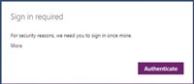
Figure 1: Microsoft sign-in page prompting the user to authenticate and proceed with multi-factor authentication setup.
- For a student, sign in with your starid@go.minnstate.edu and for employee, sign in with your starid@minnstate.edu in the screen shown below. Click on Next and enter your password. If you are already signed into your email on the browser, it will automatically take you to the next step.
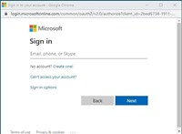
Figure 2: Microsoft 365 sign-in screen where users enter their StarID email address and password before continuing.
- From the image below, click on Next
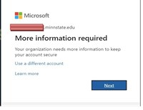
Figure 3: Security setup screen prompting the user to click ‘Next’ to continue configuring multi-factor authentication.
- This will bring up the Multi-Factor Authentication enablement screen. Click on the link “additional security verification”
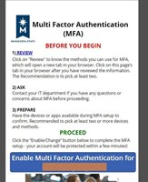
Figure 4: Microsoft security page displaying a link for ‘Additional security verification’ to begin MFA setup.
- The image below opens up in a new tab after enabling Multi Factor Authentication, you can either click on “Here” or the Website link that is underlined.
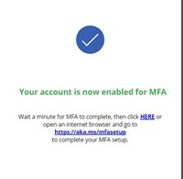
Figure 5: Multi-factor authentication setup page opened in a new tab with a link to proceed to security verification options
- From the image below, select United State as your country or region and then type in your cell phone number in the textbook and then select the option to send a code by text message. Click Next when you are done.
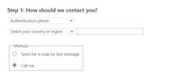
Figure 6: Form where the user selects United States, enters a mobile phone number, and chooses to receive a verification code by text message.
- As shown below, you will be prompted to enter the verification code you received on your phone in the screen below. Enter the code and click on Verify.
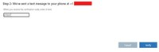
Figure 7: Verification screen prompting the user to enter the code received on their phone and click ‘Verify.
- After the code has been verified, click on Done.
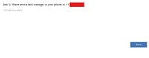
Figure 8: Confirmation screen indicating the verification code was accepted, with an option to click ‘Done.
- It will prompt you to sign in again with your credentials and you will need to verify your login with another code. Complete one more Additional security verification as show below, either by checking your office phone or alternate authentication phone or authenticator app or Token and click on Save. Note: Your assigned work phone number will be displayed automatically. If you assigned phone extension is your department number, check the box for Alternate authentication phone and then type in your assigned personal extension. If you a question any questions about the number that is displayed there, please contact the TRC at TRC@smsu.edu or call at 507-537-6111
If you choose to use the Authenticator app or Token, please watch the video in the link.
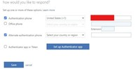
Figure 9: Security settings screen showing options for additional verification methods such as office phone, alternate phone, authenticator app, or token.
- Click back to the Multi Factor Authentication tab or click on this link. Click on Enable MFA for….. to complete the set up process.
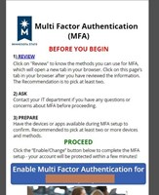
Figure 10: Microsoft MFA setup page with instructions and ‘Proceed’ button to begin enrollment.
- You have then completed the step successful
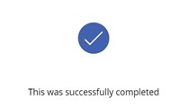
Figure 11: Final setup screen with an option to enable multi-factor authentication and complete the enrollment process.
Note that you will be prompted for multi factor authentication login each time you login to your email on a different device. Other Microsoft apps like Outlook, Teams and OneDrive will also prompt you for verification.

Change Verification Method
If you get a new device, change your phone number, lose access to your preferred sign-in method, or simply want to add a new device for authentication, you can use this link to view your current sign-in methods and make any necessary changes.
You may select "+ Add method" to add a new sign-in method, or choose "Change" to edit an existing method.
Please note: if you select "Sign out everywhere" you will be signed out of all devices where you are currently signed in. We strongly recommend that you have at least one sign-in method set up before using this option.
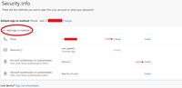
Figure 12: Security info page showing MFA methods with authentication phone option highlighted.
Please contact the Technology Resource Center at TRC@smsu.edu or call at 5075376111 if you have any question regarding this process.
Accessibility Review & Update Log:
- [x] Content accuracy and link integrity verified
- [x] High-contrast visual hierarchy implemented (Inter and Calibri)
- [x] Image alt-text captions verified (all screenshots captioned)
- [x] Outline headers and standard list sequences optimized for screen readers

